# Lesson 4 Step 3 Interior Design Fundamentals: Design Principles Synthesis

Having developed spatial awareness through your previous work on Space Analysis Integration, you're now ready to learn how to document and apply design principles in a professional manner. This skill bridges theory with practice—transforming your analytical abilities into tangible design decisions. The documentation techniques you'll master today form the foundation of professional interior design practice and will directly support your upcoming Professional Development Planning by establishing the methodical approach needed for success in your HNC studies.



Fig.1 (Thirdman on [Pexels](https://www.pexels.com/photo/8485587/), 2025) Professional documentation combines physical samples with digital tools to create comprehensive design records that communicate effectively with clients and contractors.

## 1. Design Elements Application

### Color Scheme Documentation

Professional designers document existing color schemes with systematic precision. Consider this documentation as crafting a color story for your space—a narrative that captures not just which colors exist, but how they interact, transform under different lighting conditions, and ultimately shape the experience of being in that environment. We'll now examine this crucial skill in detail.

1. **Create a visual color inventory**:

• Photograph the space in natural light without flash • Capture close-up detail shots of key color elements • Record the same colors under different lighting conditions (morning vs. evening)

1. **Develop technical color documentation**:

• Record exact color specifications rather than subjective descriptions • Document using professional color systems (paint numbers, RGB/HEX codes, Pantone references) • Note color locations and applications throughout the space

1. **Document color relationships**:

• Create a hierarchical color map showing dominant and supporting colors • Note the visual impact of different color combinations • Record how colors interact with materials and lighting

**Try this when documenting an existing space for your portfolio:** **Primary Documentation**:

* [Color name]: [Specific color code] - Location: [Placement]

• Lighting variation: [How the color appears in different light] • Adjacent material interaction: [How the color relates to neighboring materials] **Color Relationship Documentation**:

* Document how colors interact with each other
* Record how colors support or define different functional zones
* Note emotional and spatial effects created by the color combinations

**Note:** Color codes can be found on paint chips, using color-matching apps, or by using the color picker tool in design software. For example, a white wall might be "Dulux White Cotton" or "#FFFFFF" in HEX code.

Take a photo of your documentation to reference for future projects.

### Texture and Pattern Analysis

Textures and patterns create visual interest and emotional responses in spaces. When you run your hand across a rough stone wall or notice how light plays across a woven fabric, you're experiencing the power of texture to engage our senses. Similarly, patterns can establish rhythm and movement within a space, guiding the eye and creating visual harmony. Now we'll examine how to properly document these key design elements.

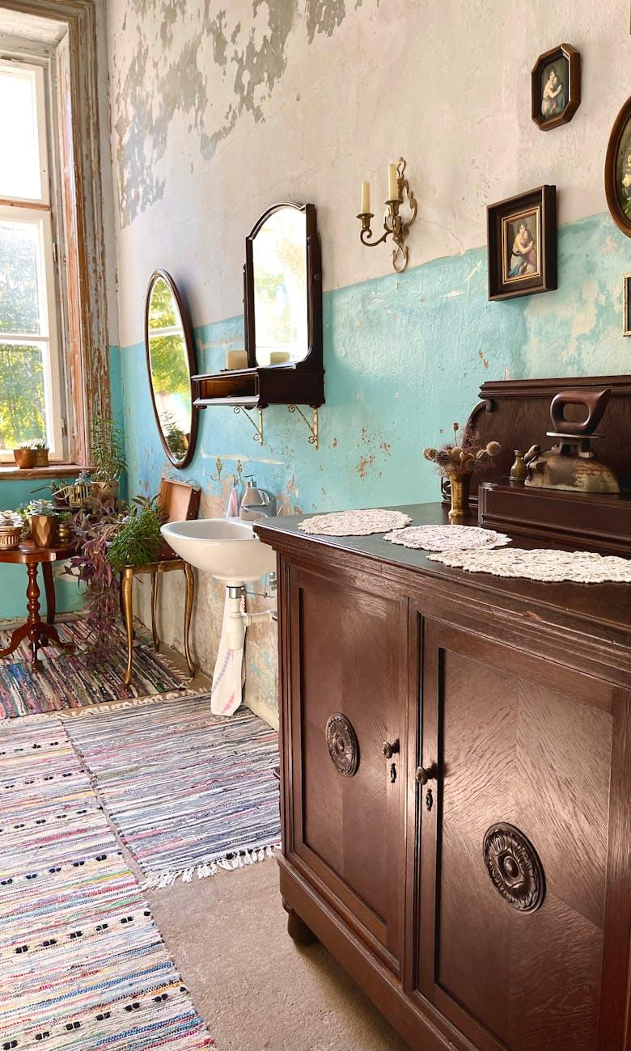

Fig.2 (Indre Mi on [Pexels](https://www.pexels.com/photo/14233081/), 2025) Effective interior design relies on thoughtful texture combinations that create visual interest and tactile experiences, even within a limited color palette.

1. **Document textures using descriptive terms:** rough, smooth, matte, glossy, etc.
2. **Record pattern types:** geometric (shapes and lines), organic (natural forms), abstract, etc.
3. **Note scale relationships** between different patterns

**Common Misconception:** Many beginners focus only on color while overlooking texture. Even monochromatic spaces (spaces using one color) rely heavily on texture variation for visual interest.

**Try this during your next visit to any interior space:**

Create a simple grid to record texture and pattern information:

| Element | Texture | Pattern | Visual Weight | | :---- | :---- | :---- | :---- | | Sofa | Plush | None | Heavy | | Cushions | Woven | Geometric | Medium |

Physically touch each surface as you document to better understand its tactile qualities.

Circle the textures that create the strongest emotional response for you.

### Material Selection Process

Professional material selection follows specific criteria that balance aesthetics with practicality. When choosing materials for a client's home or a commercial space, you're making decisions that will impact not just how the space looks, but how it functions for years to come. A beautiful marble countertop might be visually stunning, but if it's in a busy family kitchen, you'll need to consider maintenance requirements and durability. The following framework offers a systematic approach to material selection.

* Functionality (durability, maintenance requirements)
* Aesthetics (color, texture, pattern)
* Budget constraints
* Sustainability considerations

**Documentation Example:**

Material: Wood Flooring Type: Engineered oak Supplier: [Name] Cost: £X per square meter Durability: Medium-high (suitable for high-traffic areas) Maintenance: Sweep regularly, occasional refinishing Location: Living room and hallway

## 2. Space Planning Integration

### Furniture Arrangement Documentation

Building on your previous space analysis, document furniture arrangements using these principles. Remember that furniture placement isn't just about fitting pieces into a room—it's about creating functional zones, facilitating movement, and supporting the activities that will take place in the space. Effective furniture documentation communicates both the positioning of items and the rationale behind their arrangement.



Fig.3 (Antoni Shkraba on [Pexels](https://www.pexels.com/photo/5244024/), 2025) Professional space planning involves mapping functional zones, traffic patterns, and focal points to create intuitive, comfortable environments that support intended activities.

1. **Create a scaled furniture plan** showing exact placement
2. **Mark conversation areas:** Seating should be arranged within 2-2.5m for comfortable interaction
3. **Indicate traffic flow:** Allow minimum 75cm pathways between furniture
4. **Note focal points:** Document how furniture orientation relates to architectural features (like windows or fireplaces)

**Try this when developing your next room layout:**

On your floor plan, use different colored pencils or digital layers to mark:

* Primary traffic paths (red)
* Secondary movement routes (orange)
* Conversation zones (blue circles)
* Focal points (star symbols)

Review your plan from a distance to evaluate if it creates intuitive movement through the space.

Ask yourself: "Could someone navigate this space blindfolded based on intuitive flow?"

### Lighting Documentation

Document lighting using these professional categories. Lighting is often called the jewelry of interior design—it can transform a space completely and highlight its best features. But effective lighting design goes beyond aesthetics; it supports the functions of each area and creates appropriate moods. A comprehensive lighting plan should include both technical details and the intended atmospheric effects.

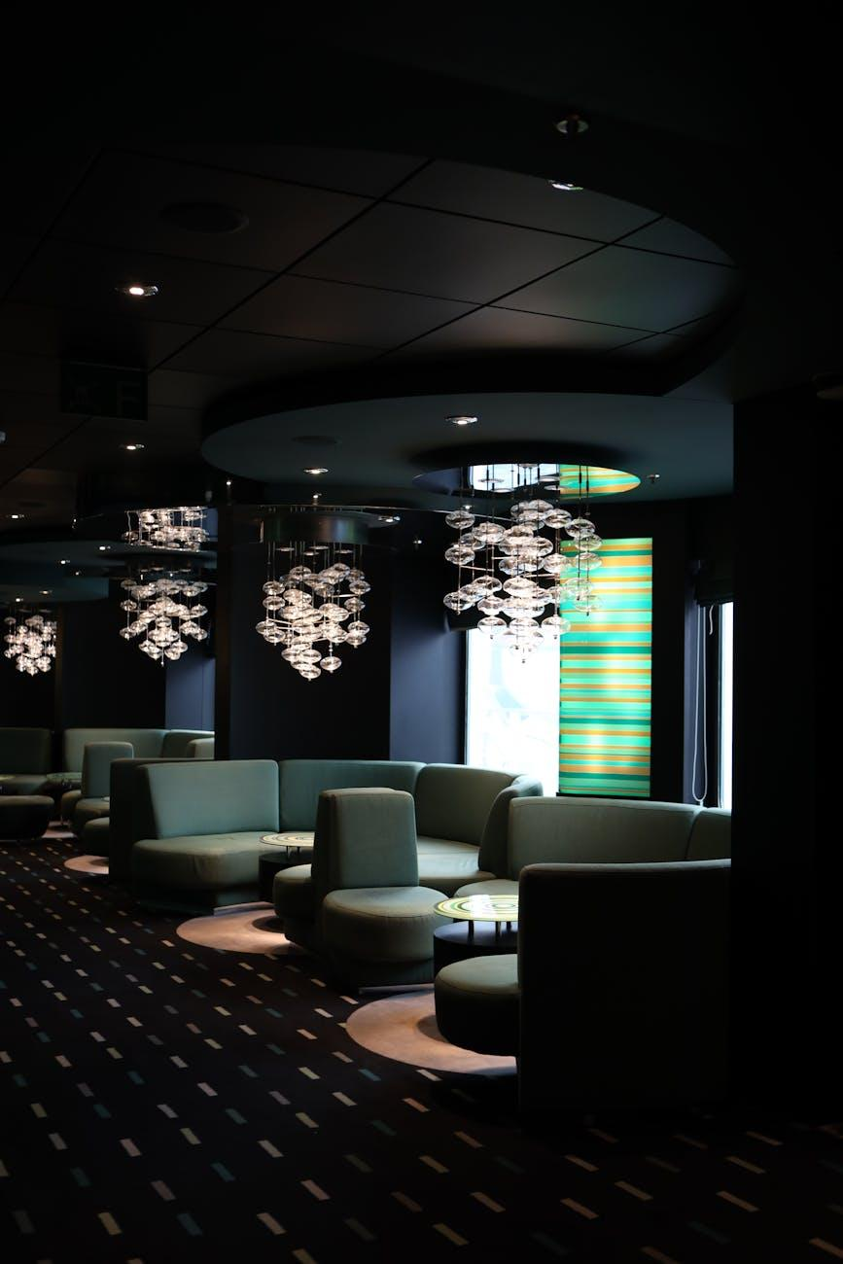

Fig.4 (Elizabeth Ferreira on [Pexels](https://www.pexels.com/photo/24643918/), 2025) Strategic lighting design combines ambient, task, and accent lighting to create layers that transform spaces throughout the day while supporting different activities and moods.

* **Ambient lighting:** General illumination (ceiling fixtures, recessed lights)
* **Task lighting:** Functional light for specific activities (reading lamps, under-cabinet)
* **Accent lighting:** Highlights features (picture lights, wall washers)

**Try this when planning a lighting scheme for any room:**

On your floor plan, mark lighting positions using standard symbols and create a simple lighting schedule:

| Fixture | Type | Location | Purpose | Bulb Specification | | :---- | :---- | :---- | :---- | :---- | | Pendant | Ambient | Dining area | General illumination | LED, 2700K, 800 lumens | | Wall sconce | Accent | Above fireplace | Highlight artwork | LED, 3000K, 400 lumens |

**Try this:** 2700K refers to color temperature (warm/yellow light), while lumens measure brightness. These specifications are typically found on light bulb packaging. Observe how the lighting transforms the atmosphere at different times throughout the day.

Identify which lighting fixture creates the most dramatic effect in the space.

### Room Feature Analysis

Document how your design responds to existing architectural elements. Every space has inherent characteristics that can either enhance or challenge your design. The mark of a skilled designer is the ability to work with these existing features—turning potential obstacles into design opportunities. Your design plan should illustrate how your decisions integrate with and respond to the architectural framework of the space.

* Window positions (for natural light and view considerations)
* Door swings and clearances
* Built-in features (fireplaces, niches)
* Structural elements (columns, beams)

## 3. Design Principles Documentation

### Documenting Balance and Harmony

When documenting how balance and harmony work in your design, you're essentially mapping out the visual and emotional experience of the space. These principles might seem abstract, but they have concrete impacts on how people feel in a room. A space with poor balance can feel uncomfortable without visitors even knowing why, while harmonious design elements create a sense of rightness and ease. Your analysis should articulate these subtle but powerful relationships.

1. **Identify the type of balance** used in each space:

* Symmetrical (formal, mirrored elements)
* Asymmetrical (visual weight distributed unevenly but balanced)
* Radial (elements arranged around a central point)

1. **Document harmony elements** by noting how colors, textures, and forms relate to each other:

Harmony Analysis: Living Room

* Color harmony: Analogous scheme using blues and greens
* Texture harmony: Contrast between smooth leather and rough woven textiles
* Form harmony: Repeated curved elements in furniture and accessories

### Proportion and Scale Documentation

Just as a composer carefully arranges musical notes to create harmony, designers must thoughtfully consider proportion and scale to create spaces that feel intuitively "right." When elements are properly scaled and proportioned, they create a sense of visual comfort that may go unnoticed—but when these relationships are off, even untrained eyes can sense something is wrong. Let's explore how to document these crucial spatial relationships in a way that will strengthen your design decisions and communicate them effectively to others.

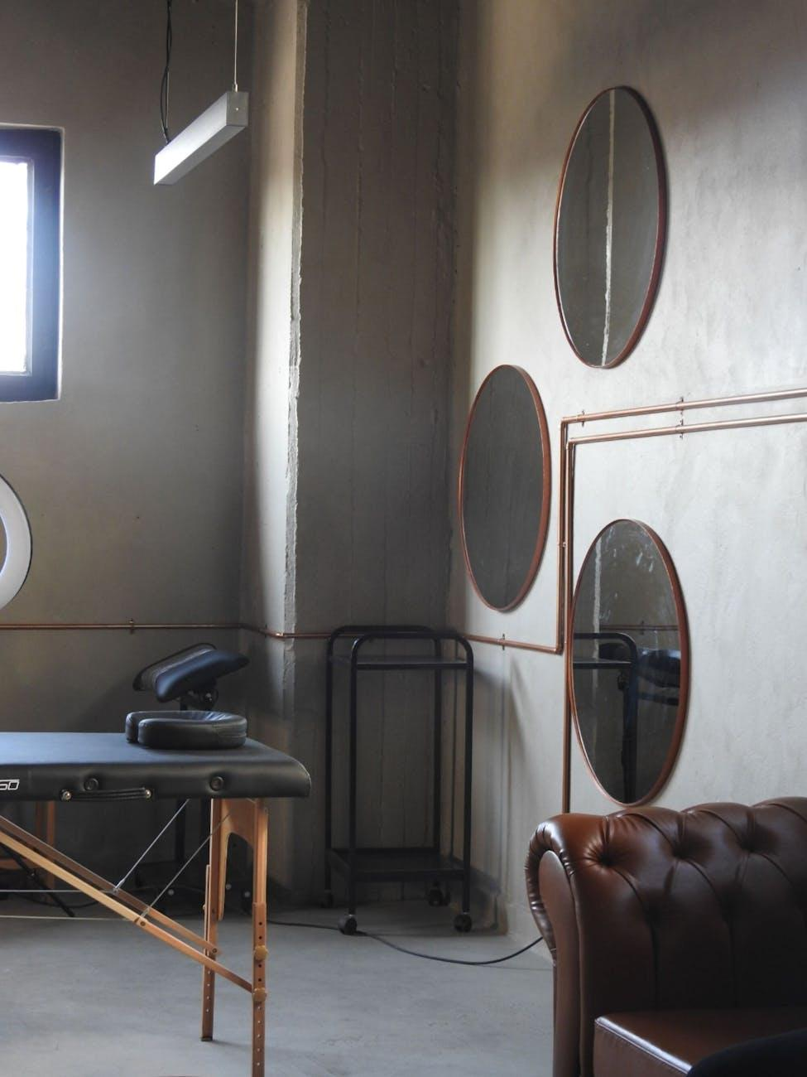

Fig.5 (Sıla ylmaz on [Pexels](https://www.pexels.com/photo/17709394/), 2025) Successful interior design relies on proper proportional relationships between elements, creating spaces that feel intuitively balanced and comfortable for human occupation.

1. **Measure and record key ratios** between elements (e.g., coffee table width is 2/3 of sofa length)
2. **Note human-scale considerations** (e.g., counter height at 90cm for comfortable use)
3. **Document ceiling height relationship** to furniture and room dimensions

**Try this when analyzing proportions in your own living space:** Scale Analysis: Dining Area

* Table dimensions: 180cm x 90cm (seats 6-8 people)
* Clearance around table: 100cm minimum for chair movement
* Pendant light height: 70cm above table surface
* Room proportion: Length is 1.6x width (follows golden ratio)

Physically move through the space and make note of any areas that feel cramped or awkward.

Identify one element you could resize to improve the overall proportional harmony.